Experiment No – 02

Title - Write a program to find largest of three numbers using nested if statement.

Theory-

The if-else statement in C is used to perform the operations based on some specific condition. The operations specified in if block are executed if and only if the given condition is true. There are the following variants of if statement in C language.
- If statement
- If-else statement
- If else-if ladder
- Nested if

if Statement-

The if statement is used to check some given condition and perform some operations depending upon the correctness of that condition. It is mostly used in the scenario where we need to perform the different operations for the different conditions. The syntax of the if statement is given below.
if(expression)
{
//code to be executed
}
The flow chart of if statement is

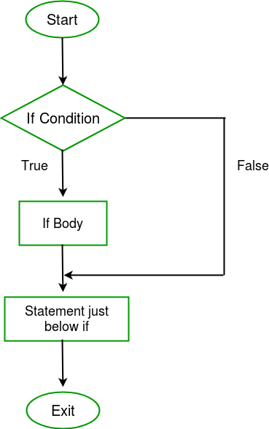
The if statement evaluates the test expression inside the parenthesis ().
- If the test expression is evaluated to true, statements inside the body of if are executed.
- If the test expression is evaluated to false, statements inside the body of if are not executed.
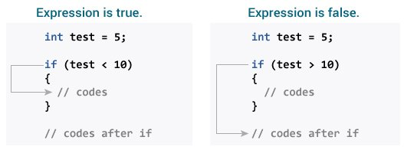

if- else statement-
The if statement may have an optional else block. The syntax of the if..else statement is:

if (test expression)
{
// run code if test expression is true
}
else {
// run code if test expression is false
}
The flow chart of if-else statement is
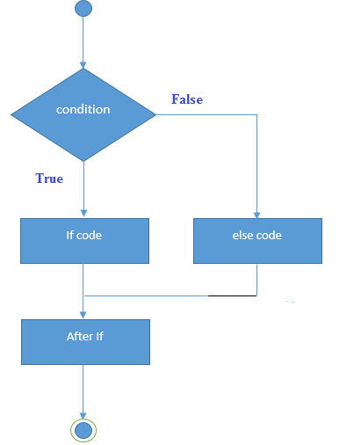
If the test expression is evaluated to true,
- statements inside the body of if are executed.
- statements inside the body of else are skipped from execution.
If the test expression is evaluated to false,
- statements inside the body of else are executed
- statements inside the body of if are skipped from execution.
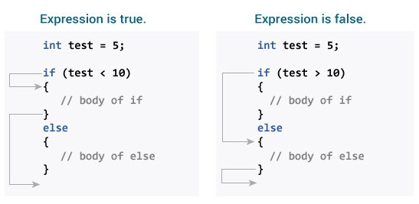
If-else-if ladder-

The if...else statement executes two different codes depending upon whether the test expression is true or false. Sometimes, a choice has to be made from more than 2 possibilities. The if...else ladder allows you to check between multiple test expressions and execute different statements.

Syntax of if...else Ladder
if (test expression1)
{
// statement(s)
}
else if(test expression2)
{
// statement(s)
}
else if (test expression3)
{
// statement(s)
}
.
.
else
{
// statement(s)
}

Flowchart of if-else-if ladder is
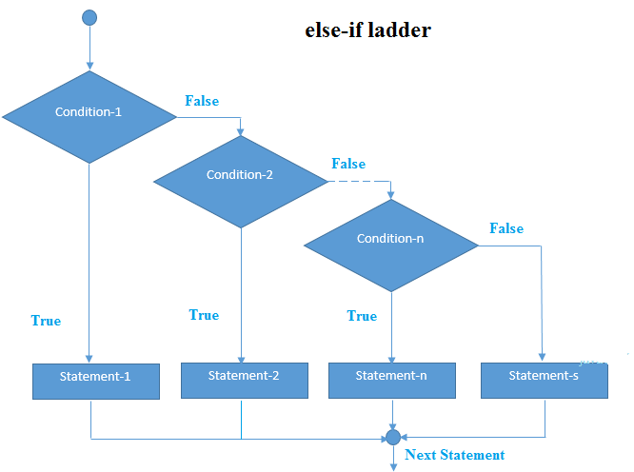

Nested-if statement-

A nested if in C is an if statement that is the target of another if statement. Nested if statements mean an if statement inside another if statement. Both C and C++ allow us to nested if statements within if statements, i.e, we can place an if statement inside another if statement.

Syntax
if (condition1)
{
// Executes when condition1 is true
if (condition2)
{
// Executes when condition2 is true
}
}

The flowchart of nested-if statement is-
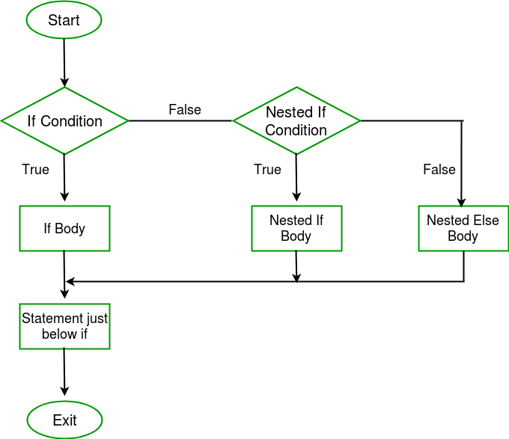

Exercise-
  - Write a C program to find maximum between three numbers.
  - Write a C program to check whether a number is negative, positive or zero.
  - Write a C program to check whether a character is alphabet or not.
  - Write a C program to find the eligibility of admission for a professional course based on the following criteria:
Eligibility Criteria : Marks in Maths >=65 and Marks in Phy >=55 and Marks in Chem>=50 and Total in all three subject >=190 or Total in Maths and Physics >=140

